**why we should learn Data Structures**

**H**ere are the most common data structures you could have learnt/known:

1. **STACK:** stack is the most common data structure



1. **QUEUE:**



1. **LINKED LIST:**

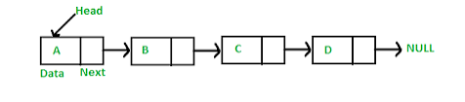

1. **TREE :**

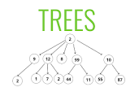

**N**ow the question is why??? We should learn them???:

Data structures are basically a form/type of container for holding data. They’re made for the feasibility purpose, with data strctures in hand you don’t need to work your logic entirely ,you could use them for increasing performance and time saving purpose.

You could have heard above frameworks like angular,react,Django,.NET etc

They’re basically there to use them as a kinda template sorta thing. Just think of a ppt template for different purposes existing in the powerpoint . without the templates you have to start your work from level 0

Just like a powerpoint template, data structures are used for real world applications.

Some applications are:

* Web browser : forward and backward buttons are based on linkedlist.
* Machine leaning : BST are used for building models
* Printer: uses a queue data structure
* Conversions: the stack can be used to convert some infix expression into its postfix equivalent, or prefix equivalent. These postfix or prefix notations are used in computers to express some expressions